DB PROJECT REPORT

MUJAHID ABBAS
22I-1969

TALHA KAYANI
22I-1914

Introduction
This project manages data for an enterprise involving departments, vendors, contracts, purchase orders, and other operational entities. It integrates database design, triggers for automated actions, and a Node.js server for API operations. Additionally, it includes a feature for sending and receiving messages.
1. ERD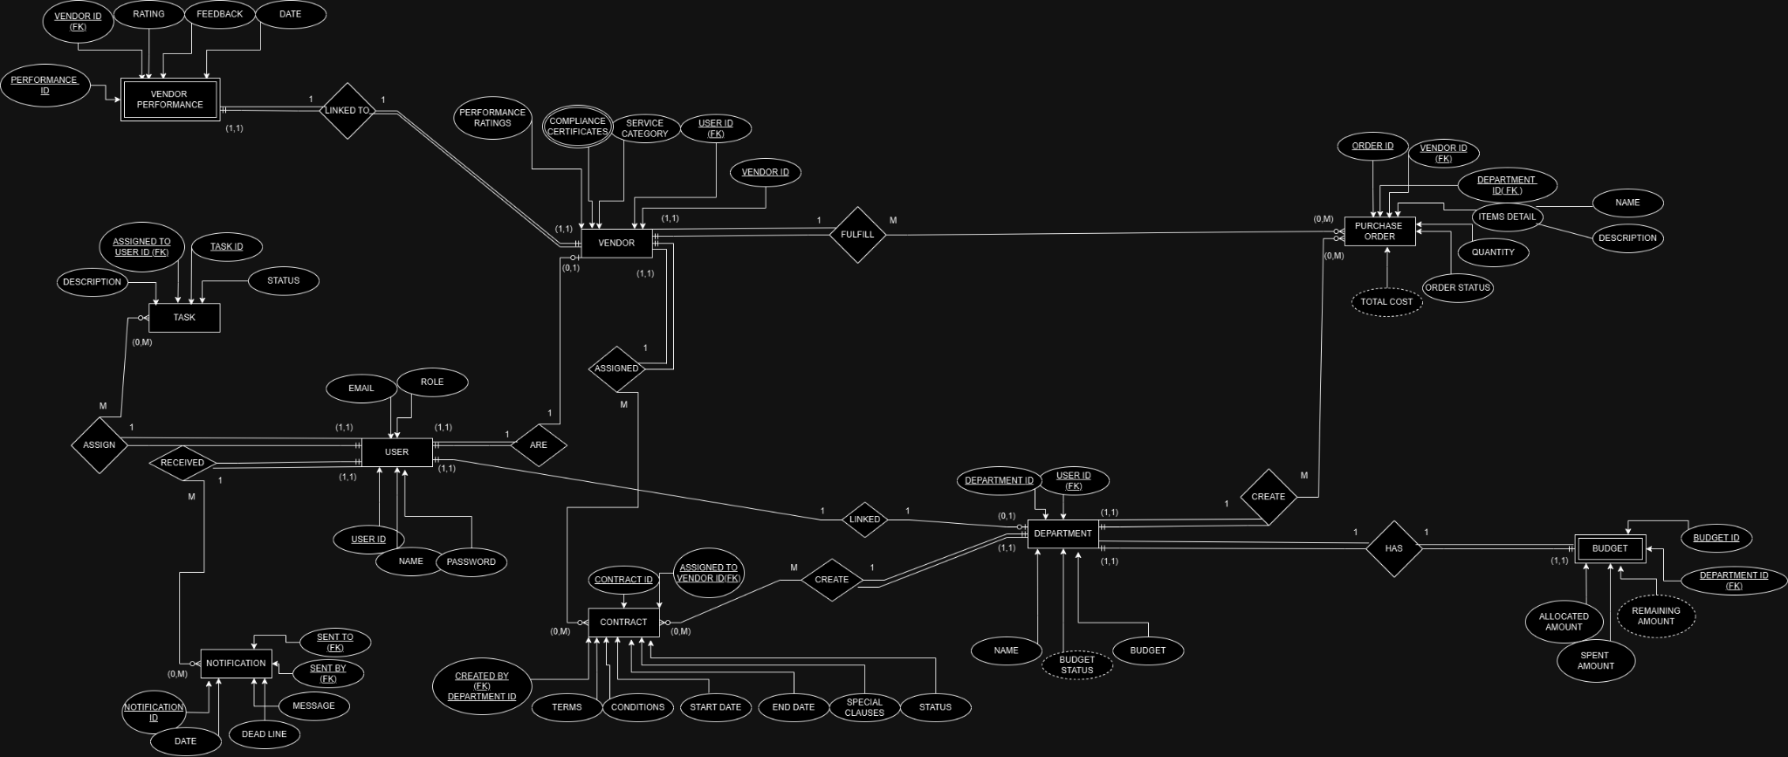

2. RELATIONAL SCHEMA
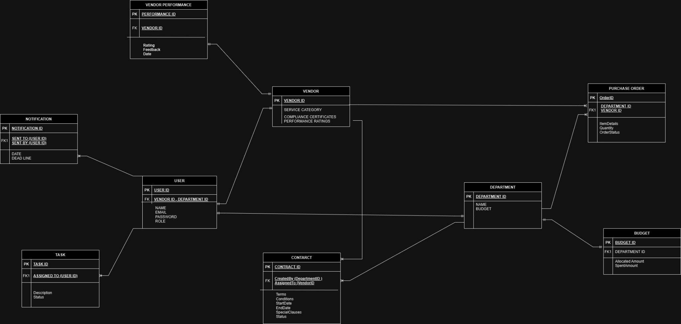

3.Table description using DESC command
User Table

Field | Type | Null | Key | Default | Extra
UserID | INT | NO | PRI | NULL | AUTO_INCREMENT
Name | VARCHAR(100) | NO |  | NULL
Email | VARCHAR(100) | NO | UNI | NULL
Password | VARCHAR(255) | NO |  | NULL
Role | ENUM('Vendor', 'Department') | NO |  | NULL

Vendor Table

Field | Type | Null | Key | Default | Extra
VendorID | INT | NO | PRI | NULL | AUTO_INCREMENT
UserID | INT | NO | MUL | NULL
ServiceCategory | VARCHAR(100) | NO |  | NULL
ComplianceCertifications | TEXT | YES |  | NULL
PerformanceRating | FLOAT | YES |  | NULL

Department Table
Field Type Null Key Default Extra
DepartmentID INT NO PRI NULL AUTO_INCREMENT
UserID INT NO MUL NULL
Name VARCHAR(100) NO NULL
Budget DECIMAL(10,2) NO NULL
BudgetStatus ENUM('Within Budget',
'Exceeded Budget') NO NULL

Contract Table

Field Type Null Key Default Extra
ContractID INT NO PRI NULL AUTO_INCREMENT
CreatedBy INT NO MUL NULL
AssignedTo INT NO MUL NULL
Terms TEXT YES NULL
Conditions TEXT YES NULL
StartDate DATE NO NULL
EndDate DATE NO NULL
SpecialClauses TEXT YES NULL
Status ENUM('Pendi NO NULL
ng', 'Accepted',
'Rejected')

PurchaseOrder Table

Field | Type | Null | Key | Default | Extra
OrderID | INT | NO | PRI | NULL | AUTO_INCREMENT
VendorID | INT | NO | MUL | NULL
DepartmentID | INT | NO | MUL | NULL
ItemDetails | TEXT | NO |  | NULL
Quantity | INT | NO |  | NULL
TotalCost | DECIMAL(10,2) | NO |  | NULL
OrderStatus | ENUM('Created', 'Fulfilled', 'Cancelled') | NO |  | NULL
VendorPerformance Table
Field Type Null Key Default Extra
PerformanceID INT NO PRI NULL AUTO_INCREMENT
VendorID INT NO MUL NULL
Rating FLOAT NO NULL
Feedback TEXT YES NULL
Date DATE NO NULL

Budget Table
Field Type Null Key Default Extra
BudgetID INT NO PRI NULL AUTO_INCREMENT
DepartmentID INT NO MUL NULL
AllocatedAmount DECIMAL(10,2) NO NULL
SpentAmount DECIMAL(10,2) NO NULL
RemainingAmount DECIMAL(10,2) NO NULL

Task Table
Field Type Null Key Default Extra
TaskID INT NO PRI NULL AUTO_INCREMENT
AssignedTo INT NO MUL NULL
Description TEXT NO NULL
Status ENUM('Pendin NO NULL
g', 'In Progress',
'Completed')

Notification Table
Field Type Null Key Default Extra
NotificationID INT NO PRI NULL AUTO_INCREMENT
Message TEXT NO NULL
SentTo INT NO MUL NULL
SentBy INT NO MUL NULL
Date DATETIME NO NULL
Deadline DATE NO NULL
4. Description of All Files
DDL Script (ddlscript.sql)
The DDL Script (ddlscript.sql) defines the structure of the database for the VendorContractManagement system. It includes SQL commands to create essential tables like User, Vendor, Department, Contract, PurchaseOrder, VendorPerformance, Budget, Task, and Notification. The script also establishes relationships between these tables using foreign keys and ensures data integrity through constraints such as primary keys and unique constraints. This structure supports the management of vendors, contracts, purchase orders, and other business operations.
Triggers (Triggers.sql)
The Triggers.sql file contains SQL triggers that automate database operations. These triggers are activated by events such as updates to the Contract table, logging contract modifications, and changes to Budget or VendorPerformance records. The triggers ensure real-time actions, such as logging updates and sending notifications, without manual intervention, maintaining data consistency and streamlining operations within the system.
Server Code (server.js)
The server.js file, built with Node.js, manages the server-side logic for the VendorContractManagement system. It defines RESTful API endpoints to handle CRUD operations on database tables and allows for sending and receiving messages between departments and vendors. The server includes middleware for parsing JSON and handling CORS, ensuring secure and dynamic data interactions between the client and the database. This file facilitates communication and the management of business data across the system.
contract.html
The contract.html file serves as an interface for managing contracts within the application. It provides a platform for users to create, edit, or view contract details efficiently. The file is structured with forms and input fields, enabling users to input and update contract-related information seamlessly. JavaScript scripts are likely included to ensure proper interaction and validation of user inputs, enhancing usability. Additionally, this file may be connected to backend services, which fetch existing contract data for display or save new and updated contract details into the database.
department.html
The department.html file is designed to manage department-related details in the system. It offers a well-organized interface, featuring a table or grid layout to list existing departments. Users can view, edit, or add new department entries directly from this interface. The file is likely linked to backend services, ensuring that any modifications or additions made by users are dynamically updated in the database. This functionality ensures that department records remain accurate and up to date, supporting the system's overall efficiency.
expiringcontracts.html
The expiringcontracts.html file focuses on displaying contracts that are nearing their expiration dates. Its layout typically features a list or table format, where users can view contracts with highlighted expiry dates for easy identification. This page plays a crucial role in alerting users about impending deadlines, helping them take timely actions. The file may also include filters or notification systems to further enhance user convenience, ensuring no important contract goes unnoticed.
index.html
As the main entry point for the application, index.html functions as a central dashboard or navigation hub. This file provides users with a streamlined interface to access different parts of the application, such as contracts, departments, and purchase orders. It features a centralized navigation menu, which ensures that users can move between sections effortlessly. By offering quick and intuitive access to various features, the index.html file significantly enhances the user experience.
purchaseorder.html
The purchaseorder.html file is responsible for handling the creation and management of purchase orders. It includes forms where users can input details such as item descriptions, quantities, and costs. These forms are equipped with validation scripts to ensure that the entered data meets predefined standards before submission. The file is integrated with backend services, enabling seamless saving of purchase order data into the system, ensuring that the procurement process is well-managed and documented.
receivemessage.html
The receivemessage.html file acts as the interface for viewing and managing received messages within the system. Its layout is inspired by an inbox, featuring a list of message previews and an option to view detailed message content. This file integrates with the messaging service backend to fetch messages in real-time, ensuring that users have access to the latest communications. It plays a vital role in maintaining clear and efficient communication across the application.
seebudget.html
The seebudget.html file is designed to provide users with a comprehensive view of budget-related data. It incorporates tables or visual elements such as charts to summarize budget usage, allocations, and remaining funds. By connecting to a financial database or API, the file ensures that users have access to accurate and up-to-date budget information. This feature helps users make informed financial decisions and monitor expenditures effectively.
seecontracts.html
The seecontracts.html file serves as an interface for users to view and manage contracts within the system. Its tabular layout allows for easy navigation, with options to sort and search contracts based on various criteria. The page fetches data dynamically from the database, ensuring that users always have access to the latest contract information. Additionally, the interface may include export options, allowing users to download contract data for offline analysis or record-keeping.
seevendors.html
The seevendors.html file provides an interface for managing vendor information. It features a grid or list view, displaying vendor profiles along with relevant data such as contact details and service categories. By integrating with a vendor database, this file ensures real-time retrieval of information, keeping the data current and actionable. The interface is user-friendly, making it easy for users to find, edit, or update vendor details as needed.
sendmessage.html
The sendmessage.html file offers a user-friendly interface for composing and sending messages. It features a simple form with fields for the recipient, subject, and message content, ensuring ease of use. Once the form is filled, the data is sent to the messaging backend for processing. This file plays a critical role in maintaining effective communication within the application, allowing users to quickly and efficiently send messages to other entities.
trackpurchaseorder.html
The trackpurchaseorder.html file provides users with the ability to monitor the status of purchase orders. It features progress trackers or status indicators that display the current state of each order, such as pending, approved, or delivered. This dynamic interface is connected to backend services, ensuring real-time updates. By keeping users informed about their purchase orders, this file contributes significantly to the transparency and efficiency of the procurement process.
vendor.html
The vendor.html file acts as a central interface for vendor-related activities. It includes forms and features that allow users to register new vendors or update existing vendor information. With its integration into the backend, the file supports CRUD operations, ensuring that vendor records are always up to date. This functionality is crucial for maintaining a comprehensive and accurate database of vendors.
vendorgetcontract.html
The vendorgetcontract.html file enables vendors to access their contract details securely. The interface lists all contracts associated with the logged-in vendor, providing essential information such as terms, durations, and statuses. This file ensures secure and efficient retrieval of contract data, fostering transparency and collaboration between vendors and the enterprise.
vendorgetpurchaseorder.html
The vendorgetpurchaseorder.html file is designed to allow vendors to view purchase orders addressed to them. It displays purchase order details in a structured table format, including information such as order status, items, and dates. The integration with backend services ensures that the displayed data is accurate and up to date, helping vendors manage their orders effectively.
vendorperfomance.html
The vendorperfomance.html file is focused on presenting vendor performance metrics in a clear and visually appealing manner. It uses tables and graphs to summarize key performance indicators, such as delivery timelines, order accuracy, and contract fulfillment rates. This analytics-driven approach helps stakeholders evaluate vendor performance and make informed decisions about future collaborations.
5. Assumptions
In the VendorContractManagement system, it is assumed that data entries for departments and vendors are unique, meaning that each department and vendor is identified by a distinct ID, ensuring no duplication in records. Another assumption is that contracts are associated with specific vendors but can also involve multiple departments, reflecting the real-world scenario where a single contract may have cross-departmental relevance. Additionally, it is assumed that all database interactions follow normalization principles to minimize redundancy and ensure efficient data storage. This approach helps in maintaining data integrity, reducing inconsistencies, and improving the overall performance of the database.

